Wormwood Scrubs guide
This is a guide to assist with the setting up of the course for the annual LUCA Cross-Country race at Wormwood Scrubs. You will find the map below as well as points on what3words (https://what3words.com/trick.maps.mess) to help guide you round the course as you set it up. You may find it more helpful to view what3words in satellite view.

General advice for setting up the course
- Do the course before the day of setting it up. It is extremely important to be familiar with the course and even more important to identify if there might be any issues with the course. It is also helpful to clear the course, especially in wooded areas and on narrows paths.
- Leave yourself plenty of time before the start time to set up the course. Ideally, the course should be marked out with the flags by the time athletes arrive for their warm ups.
- Please use the big LUCA feather flags to mark the start and ensure that they are sufficiently far apart so that c.30 athletes can be at the front on the start line.
- Ensure that at least one flag is visible from another. Whenever you put a flag down, make sure you can see the one before it. If you can’t, you have gone too far!
- At corners, use more flags to clearly mark out the contours of the corner.
- Where a part of the course could be ambiguous (e.g. because there are numerous paths or one part of the course is close to another), use more flags.

The course
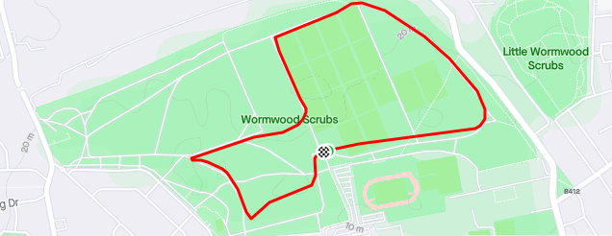

Start: soak.landed.gifted
1) teach.oasis.really
2) torn.tried.stir
3) guards.almost.shared
4) films.given.shout
5) nature.sang.closer
6) onion.rain.fell
7) perky.again.served
8) rally.scars.pool
9) state.inform.plus
10) first.plus.trunk
11) crops.feeds.sheet
12) pint.sketch.crown
13) mint.filled.draw
14) hotels.doctor.splash
15) dusty.dust.falls
16) opera.holly.orange
17) enable.gifted.bright
18) noon.estate.those
19) exist.cycles.panels
20) drip.audio.ocean
21) mops.slap.comical
22) sweat.chain.solve
23) space.poster.yards
24) studio.gears.souk
25) fats.intelligible.verse
26) dizzy.wipes.silks
Finish: To the right of the start

