Parliament Hill guide
This is a guide to assist with the setting up of the course for the annual LUCA Cross-Country race at Parliament Hill. You will find the map below as well as points on what3words (https://what3words.com/trick.maps.mess) to help guide you round the course as you set it up. You may find it more helpful to view what3words in satellite view.

General advice for setting up the course
- Do the course before the day of setting it up. It is extremely important to be familiar with the course and even more important to identify if there might be any issues with the course. It is also helpful to clear the course, especially in wooded areas and on narrows paths.
- Leave yourself plenty of time before the start time to set up the course. Ideally, the course should be marked out with the flags by the time athletes arrive for their warm ups.
- Please use the big LUCA feather flags to mark the start and ensure that they are sufficiently far apart so that c.30 athletes can be at the front on the start line.
- Ensure that at least one flag is visible from another. Whenever you put a flag down, make sure you can see the one before it. If you can’t, you have gone too far!
- At corners, use more flags to clearly mark out the contours of the corner.
- Where a part of the course could be ambiguous (e.g. because there are numerous paths or one part of the course is close to another), use more flags.

The course
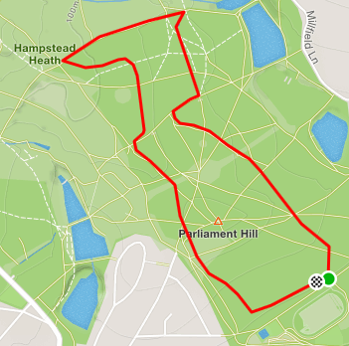

Start: common.reply.swan
1) analogy.sank.under
2) crowd.races.scars
3) legs.glad.verbs
4) trunk.flip.scar
5) plug.hunt.traps
6) trips.sage.eagle
7) poster.ledge.dive
8) funny.funds.edgy
9) dine.popped.grin
10) never.drag.hers
11) brief.vanish.pine
12) priced.rising.gone
13) burns.oppose.custom
14) circle.photo.resort
15) boost.appear.visits
16) start.reds.awake
17) intend.tags.remote
18) fame.future.wing
19) tame.wings.decide
20) organ.risky.spends
21) prep.pulse.guards
22) design.relay.milk
23) test.wider.direct
24) repay.summer.scuba
25) gained.risk.twig
26) vouch.rocket.alert
27) hers.jump.judges
28) listed.models.tribune
29) hooked.editor.smug
30) crazy.bake.square
31) reveal.until.figure
32) field.asset.pouch
33) frosted.wizard.bugs
34) logic.sport.note
35) ritual.ground.sport
36) bags.critic.codes
37) places.clear.clever
38) sung.civic.desks
39) hours.skin.bills
40) agreed.limp.minds
41) status.mostly.listed
42) soap.quite.wizard
Finish (after 41): sugar.wins.signal

