Mitcham Common guide
This is a guide to assist with the setting up of the course for the annual LUCA Cross-Country race at Mitcham Common. You will find the map below as well as points on what3words (https://what3words.com/trick.maps.mess) to help guide you round the course as you set it up. You may find it more helpful to view what3words in satellite view.

General advice for setting up the course
- Do the course before the day of setting it up. It is extremely important to be familiar with the course and even more important to identify if there might be any issues with the course. It is also helpful to clear the course, especially in wooded areas and on narrows paths.
- Leave yourself plenty of time before the start time to set up the course. Ideally, the course should be marked out with the flags by the time athletes arrive for their warm ups.
- Please use the big LUCA feather flags to mark the start and ensure that they are sufficiently far apart so that c.30 athletes can be at the front on the start line.
- Ensure that at least one flag is visible from another. Whenever you put a flag down, make sure you can see the one before it. If you can’t, you have gone too far!
- At corners, use more flags to clearly mark out the contours of the corner.
- Where a part of the course could be ambiguous (e.g. because there are numerous paths or one part of the course is close to another), use more flags.

The course
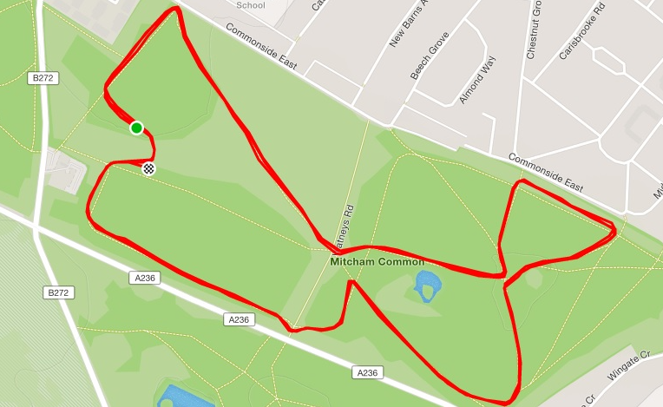

Start: trick.maps.mess
1) gasp.harp.think
2) asks.discrepancy.token
3) toward.finishing.amount
4) tamed.light.grit
5) smiled.couch.bossy
6) daring.slick.those
7) drew.single.punks
8) rent.swear.hill
9) shield.device.wing
10) limp.relax.spice
11) idea.stews.moss
12) flood.oceen.ending
13) tigers.stale.outer
14) discouraged.turned.shovels
15) seated.shared.pill
16) feeds.unless.puzzle
17) amused.woven.task
18) pardon.bubble.chat
19) worm.scale.common
20) places.slows.wonderfully
21) flank.tanks.breed
22) cones.drag.wanted
23) demand.sculpture.boxing
24) hands.pirate.royal
25) arts.amber.struck
26) paused.stores.pits
27) clues.owner.hills
28) crush.ending.note
29) angle.jelly.feast
30) melon.wisdom.stage
31) mirror.minds.tummy
32) talent.cube.food
33) pine.jumped.marble
34) rate.thus.random
35) parent.assure.that
36) rainy.human.chimp
37) wake.festivity.fight
38) link.drama.improving
39) nests.steer.froze
40) tails.proud.attend
41) aside.votes.frost
Finish (after 39): bath.fonts.lung

Marshals
If there are a sufficient number of volunteers that it is possible to have marshals, useful positions might be as follows:
1)

