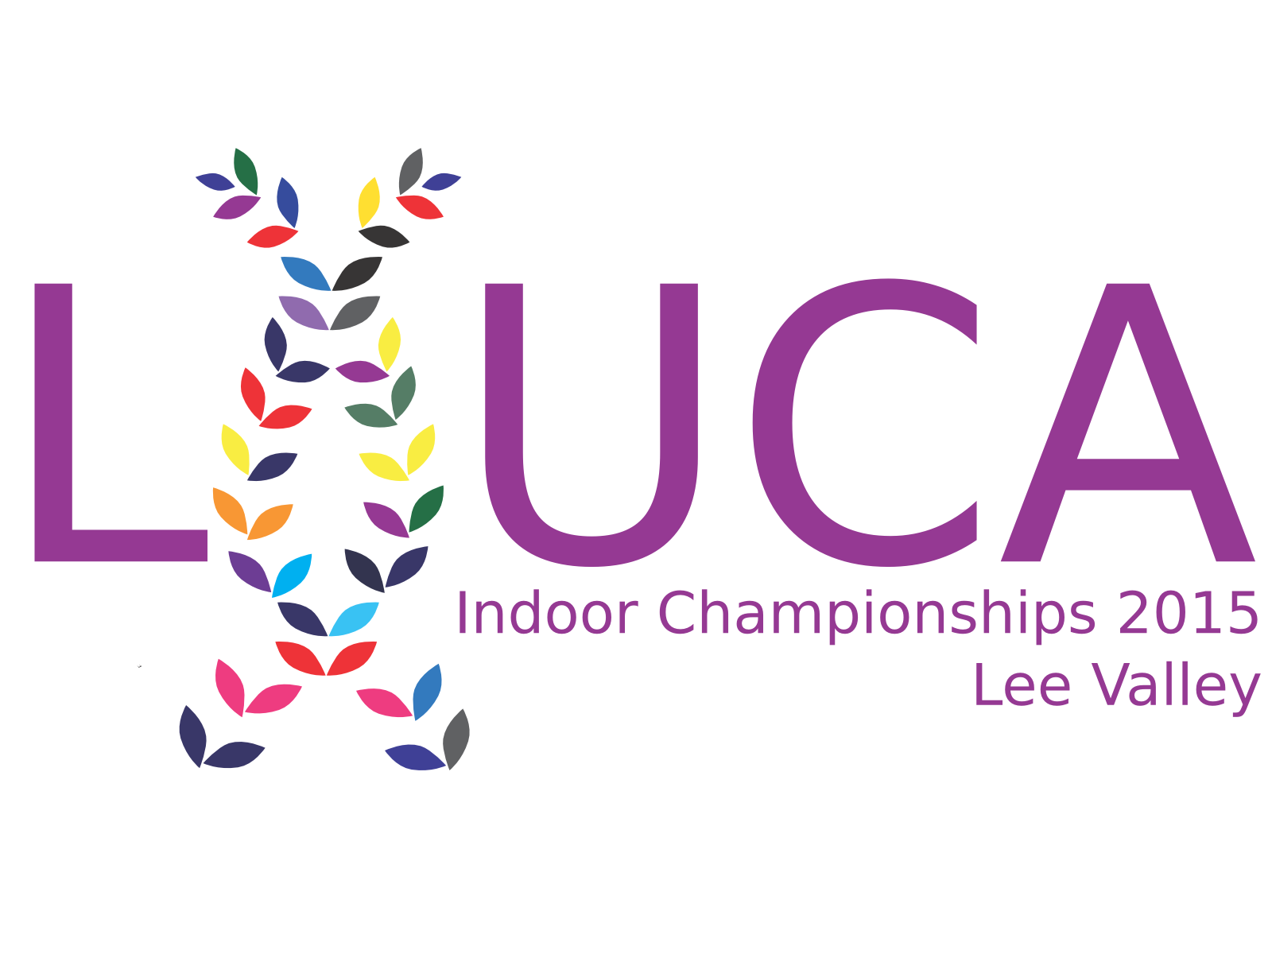
London Universities & Colleges Athletics
Indoor Championships 2015

Lee Valley, Edmonton
Sunday 24st May

60m 1500m High Jump
60mH 3000m Shot put
200m 4 X 200 Mascot Race (200m)
400m Triple Jump
800m Long Jump
Held under UKA rules
All races will have ELECTRONIC TIMING.

All LUCA member clubs are invited to take part in the first LUCA indoor championship. Nested within this championship, the colleges of the University of London will compete for the UL Athletics Championship Trophy and the medical schools of the United Hospitals will compete for the United Hospitals Athletics Championship Sheid.

There will be three attempts for each athlete in all horizontal jumps and throws.

High Jump: Female start height 1.25m. Male start height 1.40m

Timetable: Estimated 1330-1800

Details of the timetable and pools will be available on the website three days before the event.

Entry fees: £4 per event (entry fees non-refundable). Entries are limited.
To enter go to london-athletics.com/indoor

Closing date: Sunday 21st November 2015 no late entries considered

Numbers to be collected on the day or at least one hour before the start of your event
Note: We will be collecting donations for the North Enfield Foodbank. Please bring no-perishable food.

