Handbook 2016-17

London Universities and Colleges Athletics
Chairman: Arthur Wadsworth
President: James Findon
Internet: www.london-athletics.com

UCL win the Outdoor Series, 2016

LUCA Handbook
September 2016

Our members:
Bart’s and the London
Bedfordshire
Brunel
East London
Essex
Goldsmiths
Greenwich
Imperial College London
King’s College London
Kingston
London School of Economics
Queen Mary
Reading
Roehampton
Royal Holloway
RVC
SOAS
St Mary’s
University College London
University of London

Forward

London Universities and Colleges Athletics (LUCA) was established to act as a competition organiser of events for university athletics clubs in and around London. It also represents the interests of its members on a national and regional level and fosters a spirit of cooperation between clubs in order to develop athletics across the city.
LUCA was formally founded by the consent of 15 university clubs whose representatives attended the first council meeting on the 14th of October 2015 at Student Central, University of London. Since then, LUCA has grown and now has 20 full members.
In its first season, 241 people competed in the cross-country league, 230 at Indoor Championships and 210 across the outdoor championship series.
Further to this, our focus club programme has supported developing clubs at Roehampton and Essex and we have linked clubs with over £7500 of funding from England Athletics and/or London Sport.
All of this has been part of our vision to usher in a golden era of university athletics in London.
It is an ambitious aim, but with the support of student unions, sports departments, clubs, committees, coaches and athletes, we will make it happen.

James Findon
LUCA President
Contents
What is LUCA? 7
Club Development: Improving the sport we love 7
Competition Provision: Organising inspiring events 7
Student Development: Caring about students and society 8
Pillar 1: Club Development 9
LUCA Focus Clubs 10
England Athletics Funding 11
‘Run my club’ 11
Pillar 2: Competition Programme 12
The London Colleges League (LCL) 12
The LUCA Indoor Championships 16
LUCA Outdoor Series 18
Removing barriers to competition 22
Pathways for individuals 23
Widening Participation 23
This Girl Can 23
London Students’ Run 23
Pillar 3: Student Development 24
Funded coaching training 24
Funded officiating training 24
News Team 24
Scholarships 24
LUCA in the community 25
Governance 25
The board of trustees 25
The executive committee 25
The council 25
Entry Fees 26
Alumni Club 27
2016-17 Schedule 28

What is LUCA?

LUCA’s primary objective is “to improve the sport of athletics and promote it within the higher education sector in London in light of its unifying, educational, cultural and health values, particularly through competition provision and development programmes”. This objective is built on three pillars: club development, competition provision and student development.

Club Development: Improving the sport we love

We share the success of our competitions and work with our partners at England Athletics, London Region to support athletics development projects across our 20 member clubs in London and greater London. Athletics is growing at a rapid rate among the London Universities because of our support. With £8200 going into these programmes through funding and subsidies since December, LUCA is bringing more money into university athletics than ever before.
Many of our members depend on this support to finance their day-to-day operations and competition entry. It ensures that clubs receive a helping hand when starting up and that established clubs continue to thrive.

Competition Provision: Organising inspiring events

Our second objective is to organise participation friendly, professionally managed athletics competitions. LUCA’s goal is to provide a competition programme that is appealing to athletes of all abilities. We take a proactive approach in removing barriers to participation and make the most of community and professional role models to inspire the next generation.
Approximately 30% of competitors in our events have never competed in athletics before. At the same time, we have attracted top performing international standard athletes including Laviai Nielsen, Antonio Infantino and Lorn Mayers. Our XC league consistently attracts junior international athletes such as Peter Chambers (UCL) Max Nicholls (KCL), Jacob Allen (SMU), Christopher Olley (ICL) and Richard Goodman (SMU). The league includes Andy Vernon (SMU) and Mo Farah (SMU) in its hall of fame.

Student Development: Caring about students and society

Athletics is much more than just a sport and LUCA is much more than just a competition provider. We believe that our duty to our member clubs goes beyond athletics; to improve the lives of student athletes and make a positive impact on our local communities.
Athletics can be a vehicle for personal growth and career development. We recognise our role, and work hard to provide opportunities for all students to further their development by offering training as coaches, officials, journalists, competition managers, event organisers, community volunteers and more. This year, we are launching an ambitious ‘LUCA in the community scheme’ to focus our attention on what LUCA can do to benefit the wider London community.

In the next section, we will walk you through each of the three pillars of LUCA and outline the exclusive benefits of being part of our family.

Pillar 1: Club Development

Most people consider athletics as an individual sport. At LUCA, we reject the individual vs. team sport dichotomy and see athletics as a ‘club sport’. Athletes score not just for themselves, but also for their club.
We believe that the most successful means of developing athletics across the higher education sector in London is to have strong, sustainable, dynamic and diverse clubs.
LUCA member clubs have access to the following club development resources.
- Full or part-funded coach and official training courses
- Club development and management resources on www.london-athletics.com/runmyclub
- Competition organising resources
- Committee training sessions
- Focus Club eligibility

LUCA Focus Clubs

The LUCA Focus Club programme aims to provide specific and tailored support to developing athletics clubs. The programme offers;
- £500 funding from England Athletics for new sessions.
- Dedicated LUCA support officer.
- Funding for one member to do a level 1 coaching course.
- Assistance with club documents (Constitution, EA affiliation etc.).
- Link with local clubs and other university clubs.
- Link with local EA RUN! Activator.
- Half price Outdoor Series entries.
Focus club status is offered for the duration of one academic year.
2015/16 Focus Clubs
- Essex
- Roehampton
Focus Club achievements
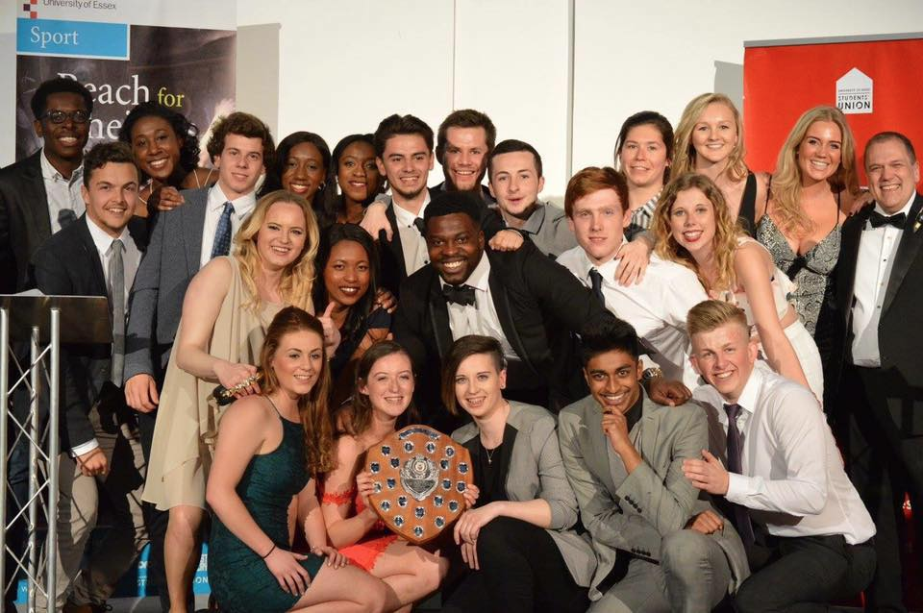
Essex
In their own words, The University of Essex Athletics Club ‘came out of nowhere’ to challenge for the Outdoor Series championship and break many records in the process. At the first outdoor series match, Essex broke the LUCA record for the most entries and athletes at a LUCA event. Essex used the focus club funding to set up ‘introduction to athletics’ sessions for new athletes. They worked in partnership with Colchester and Tendering AC to provide a full range of athletics provision to their members. Their success was recognised by their student union who awarded them ‘Sports Club of the year’. They also came third in the Outdoor Series, won a plethora of individual medals and won the LUCA best club of the year and the best club partnership.
Roehampton
In 2015, Roehampton student Jay Cornish became the first ever Outdoor series champion, winning the gold medal in the 10,000 special event in Tooting. Since then, Roehampton has became a focus club and set up a partnership with Hercules Wimbledon AC. Focus club funding has helped them set up ‘Athlefit’ sessions on campus and promote their campus 5/10K run. Roehampton provided training sessions ahead of the campus run.

England Athletics Funding
LUCA works closely with England Athletics, London Region on a range of athletics development projects. Over the period December 2015 to May 2016, LUCA has linked clubs with England Athletics funding worth £7500. This money has been spent on coaches, facility hire and coach training.

‘Run my club’
‘Run My Club’ (www.london-athletics.com/runmyclub) was set up in the summer of 2016 to act as the home of LUCA’s club development and management resources. It brings together the best of the LUCA community and allows clubs to share resources for the benefit of all clubs. ‘Run my club’ is an ever expanding list of resources and clubs are encouraged to add to this list.
Clubs also have access to our track and field meet organising guide (www.london-athletics.com/race-organising/) to help clubs organise their own open meets and varsity competitions.

Pillar 2: Competition Programme

LUCA is the organising body of three major athletics competitions:
- The London Colleges League (LCL) - Cross Country
- LUCA Indoor Championships
- LUCA Outdoor Series (Previously, London Colleges Athletics Series (LCAS))
LUCA is also responsible for organising the follow competitions, which are nested within the above:
- The University of London Cross Country Championships
- The Bannister Cup
- The University of London Athletics Championships
- The United Hospitals Athletics Championships

The London Colleges League (LCL)

The LCL was established circa 1950 as a cross-country league exclusive to London universities. From 2015-16, LUCA has had sole responsibility for the league, which was previously managed by a single secretary. The league consists of five races at different parks on a Wednesday afternoon. Races start at 15:15. There are three races in the first semester and two in the second.
Races are typically 4½ miles (7.2KM) for men and 2¼ miles (3.6KM) for women. Men and women race together and finish in the same funnel, but are classified separately.
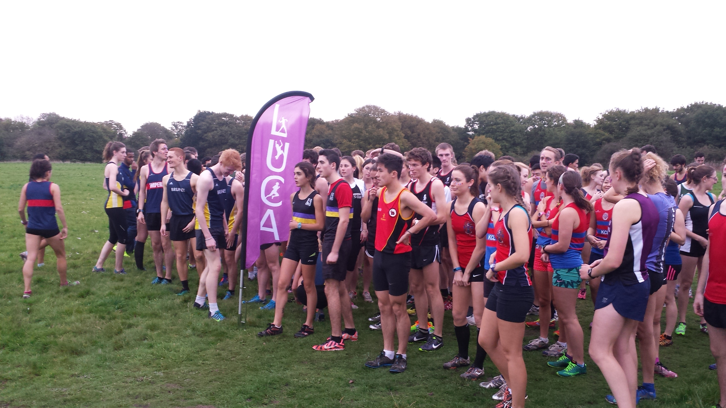

Venues and Host Clubs
Each race is hosted by a different club at a different venue across London.
1: Parliament Hill, UCL
2: Richmond/Mitcham, Imperial
3: Wimbledon, King’s
4. Alexandra Palace, LSE
5. Bushy Park, St Mary’s
Registration and Results
No pre-registration is necessary to compete in the LCL. Athletes turn up, run, and receive a token with their finishing position on it. Athletes give their token and name to a results tent. Finishing positions are linked to a manually taken time via two qualified timekeepers.
Results are published online within two days. All results are eligible for www.thepowerof10.info
Scoring
The winner of the men’s race is awarded 150 points. Second place is awarded 149, third 148, and so on. The winner of the women’s race is awarded 100 points. Second place is awarded 99, third 98, and so on.

Men’s teams are five to score. The team’s sixth finisher is a non-scoring spacer. The seventh to eleventh finishers form the second team, the twelfth runner does not count, and so on.
Women’s teams are four to score with no spacer. The fifth to eighth finishers form the second team, the ninth to twelfth the third team, and so on.
The maximum score in the men’s competition is 740, and 710 for a second team.
The maximum score in the women’s competition is 394, and 378 for a second team.
Quality assurance and risk management
The host club provides marshals and places the course markers and signs. Prior to the race, course maps are available via the website. Red flags are used to signal the route and high-vis signage is used to indicate sudden turns. Marshalls are present at ‘forks in the road’ and other areas of route ambiguity.
All races are risk assessed and relevant measures put in place to reduce risk to acceptable levels. For example, routes at Richmond and Bushy Park are designed to avoid the deer and athletes are briefed to avoid them.
Venues are chosen with consideration of appropriate facilities. All venues must have changing rooms, toilets, and drinking water availability.

The University of London Cross-Country Championship & Bannister Cup
The Bannister Cup and University of London Cross Country Championships are nested within the Wimbledon meet, hosted by King’s College London. The Bannister cup is a team cross-country competition exclusive to medical and dental school students. The University of London Championships is a cross-country competition exclusive to the colleges and institutions of the University of London. It has a individual and team championship.
The University of London (UL) cross-country championship and the Bannister Cup do not affect LCL results. Teams are not required to be LUCA Member Institutions. All colleges and institutions of the University of London are eligible to compete in the UL Championships. Members of the United Hospitals (RUMS, Barts, Imperial College School of Medicine, GKT, St George’s and RVC) are eligible to compete for the Bannister Cup.

The LUCA Indoor Championships

The first LUCA Indoor Championships were held in November 2015 and took the place of the long running University of London Athletics Championships (commonly referred to as ‘UL Indoors’). Like the UL cross-country championships and Bannister cup, the UL Indoor trophy and the United Hospitals Athletics Championship Shield are nested within the LUCA Indoor Championships.
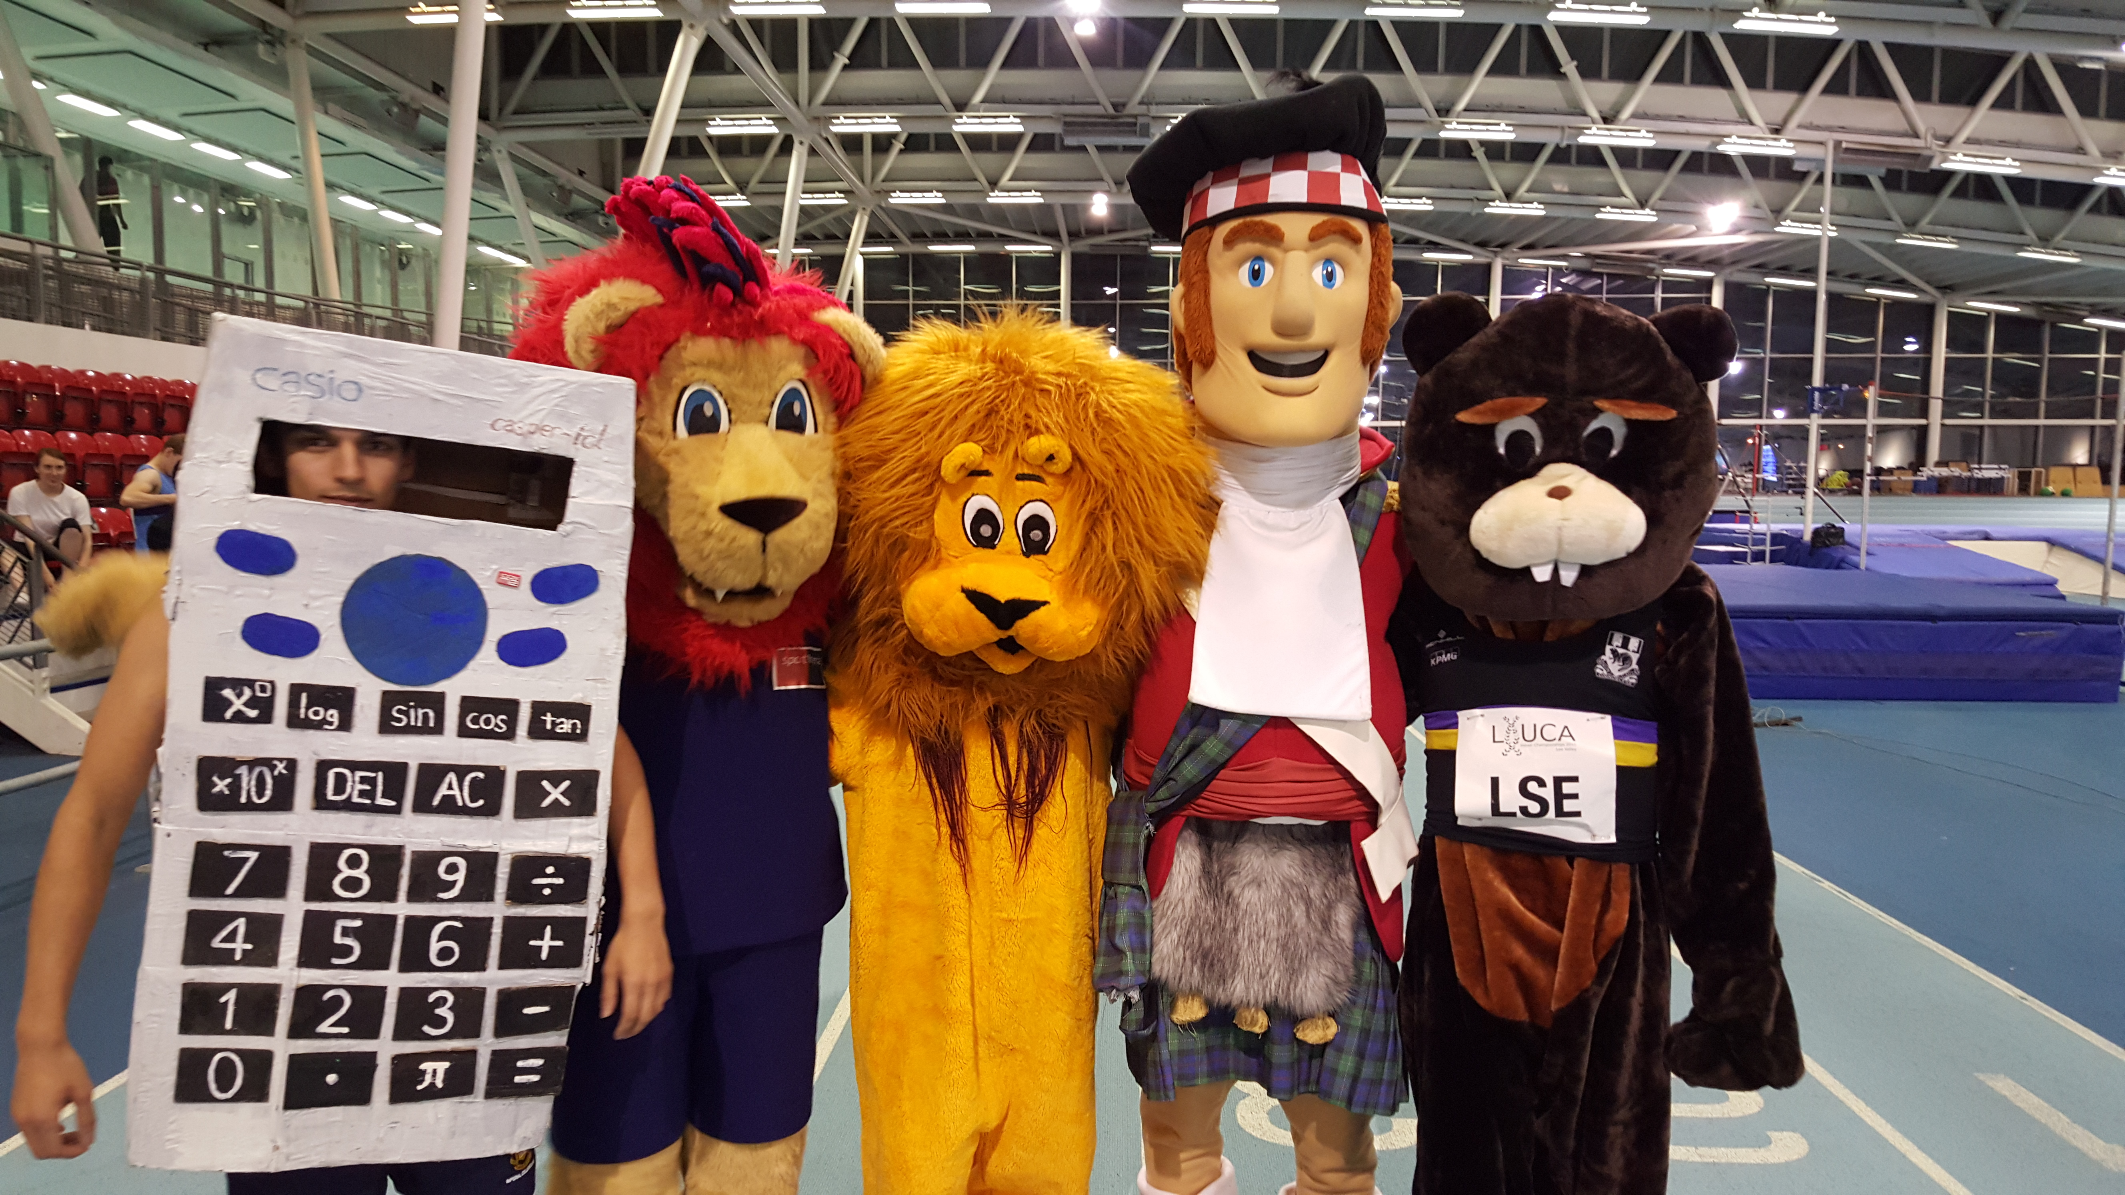
The Indoor Championships are held at Lee Valley.

Registration
Athletes at LUCA clubs:
Club captains register members through a team online application form. This form will be available on the website 1 month before the event.

Athletes not in clubs:
Athletes at universities but not involved in their athletics club can compete by completing the guest registration form. However, we advice in the first instance that they contact their university athletics club.
Athletes not at university:
We accept non-scoring guest entries at the LUCA indoor championships. Guests should complete the guest registration form online.

Scoring
A university can make unlimited entries into each event, but only two can score. Points for UL and UH are scored only considering eligible athletes.
Points are awarded to the top three finishers in the following order:
Position Points
1 4
2 2
3 1
Points for UL and UH are scored by awarding points to the top three eligible athletes.

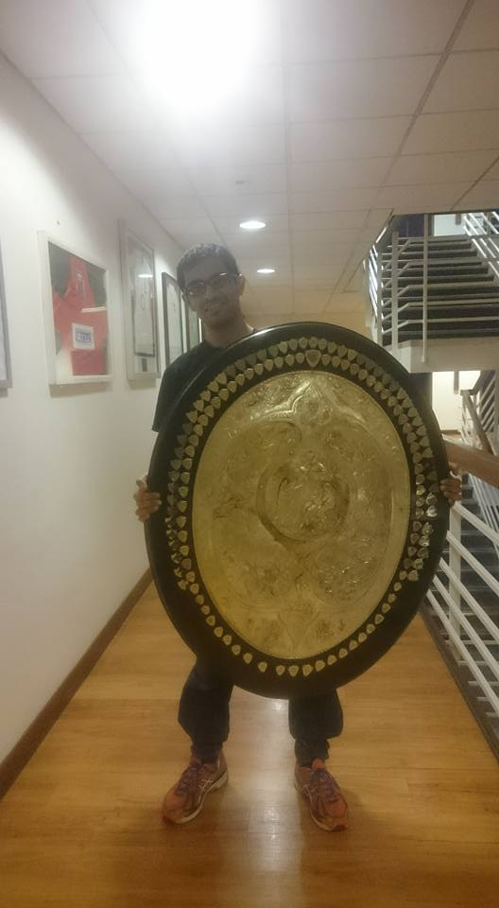
Quality assurance and risk management
We conduct a full risk assessment prior to the championships. The event is fully permitted by UKA and we fulfil the requirement to have trained officials present at all events. Results reach the criteria to be uploaded to the powerof10.info. Hence, these results can be used as a qualifying standard for BUCS Indoor Championships.

Changes in 2016
Seeding
In previous years, clubs designated an A-string athlete and unlimited B-string athletes. This system allowed the organisers to place all A-string athletes together in one or two races to ensure a spread of clubs in the fastest races. In 2016, clubs won’t designate A- or B-string athletes, but will instead solely list their personal bests. If athletes don’t have personal bests, then estimated times should be provided. Heats will be seeded according to time only. If times are not provided, athletes will be put in the later heats.

LUCA Outdoor Series

The LUCA Outdoor Series (previously, London Colleges Athletics Series (LCAS)) is a three-match track and field series held at different venues, once a month, between March and May.
The series was first held in 2015 and acted as a precursor to the founding of LUCA. The series is aimed at providing track and field competition at a participation level, however we have been successful at attracting international athletes too. There are no entry standards required.
The three venues have to conform to our quality assurance criteria, which includes;
-Must have a UKA permit
-Must have public transport links
-Must be in London
-Must have disabled access
Venues are decided by the organisation committee and publicised around October.
Registration
Athletes at LUCA clubs:
Club captains register members through a team online application form. This form will be available on the website 1 month before the event.

Athletes not in clubs:
Athletes at universities but not involved in their athletics club can compete by completing the guest registration form. However, we advise that in the first instance that they contact their university athletics club.
Athletes not at university:
We accept non-scoring guest entries at the LUCA indoor championships. Guests should complete the guest registration form online.

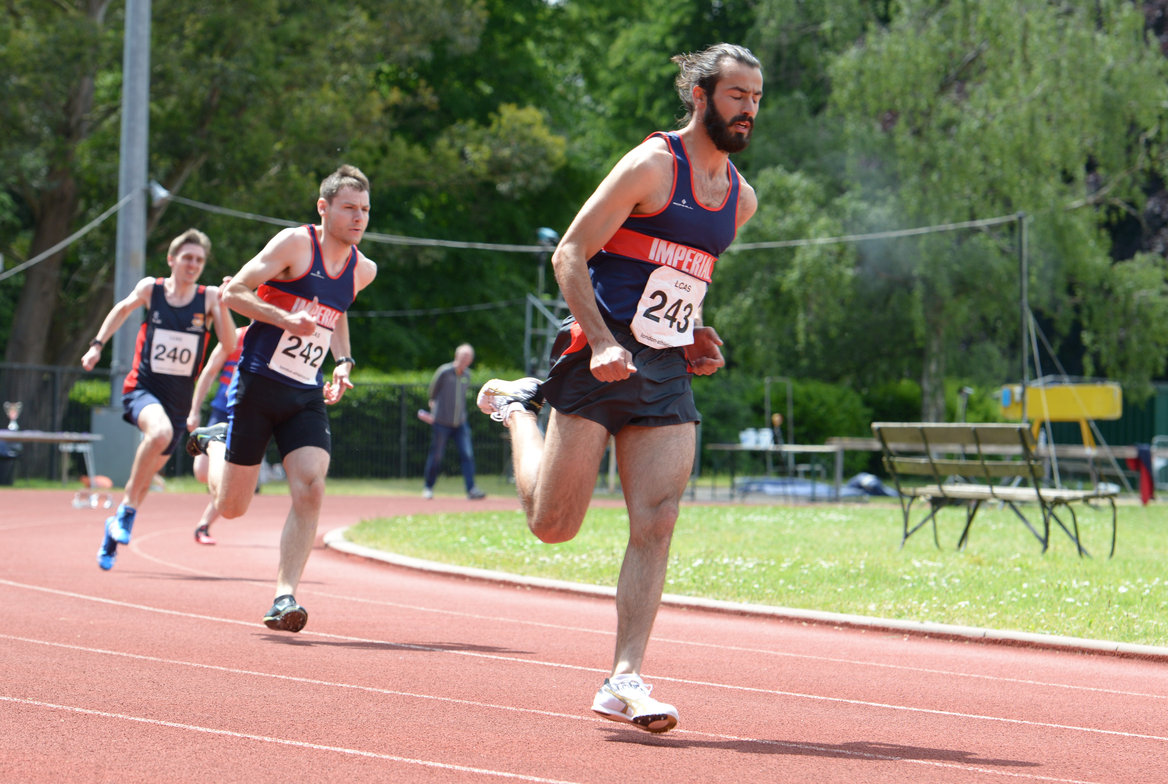

Scoring
The outdoor series is in a ‘diamond league’ format, with points gathered across all three meets in each event totalled and the highest scoring athlete awarded Gold. Points are also totalled for each university and go towards the Outdoor Series Championships Trophy. King’s College were inaugural winners and University College won in 2016.
Points are awarded to the top six finishers in the following order:
Position Points
1 7
2 5
3 4
4 3
5 2
6 1

There are two types of event at the Outdoor Series. ‘Series events’ are repeated three times across the three meets, with medals awarded at the final meet to the athletes with the most points. ‘Special events’ are straight championships, held once across the series.
Series events
100 100h
11H 200
400 800
1500 5,000
4X100 4X400
Triple Jump Long Jump
High Jump Shot Put
Javelin Discus

Special events
Match 1: 10, 000
Match 2: Multi-Event Challenge
Men: 100, 1500, shot put, high jump
Women: 200m, 800m, shot put, high jump
Match 3: Mixed Relay Medley: 2X200, 2X400, 2X800.
Six athletes make up a team. Only two teams per club score. Each distance is run by a man and a woman.
Quality assurance and risk management
We conduct a full risk assessment prior to each match. The event is fully permitted by UKA and we fulfil the requirement to have trained officials present at all events. Results reach the criteria to be uploaded to the powerof10.info. Hence, these results can be used as a qualifying standard for BUCS Indoor Championships.

Changes in 2016
  - Name
The outdoor series has changed its name from London Colleges Athletics Series (LCAS). We encourage all clubs to stop referring to the series as ‘LCAS’ and use ‘LUCA Outdoor series’ instead.
  - Provision of Officials
In recognition of the difficulty in attracting officials to these events, large clubs will be requested to provide at least two officials per meet. To aid in this transition, LUCA has teamed up with EA to provide a fully funded and mentored officiating training programme (see below).
  - Seeding
In previous years, LUCA had the policy to include a spread of university’s in the top heats. However, after a vote from the council, seeding will now be solely reliant on reported personal bests. If athletes don’t have personal bests, then estimated times should be provided. If times are not provided, athletes will be put in the later heats.

Removing barriers to competition

LUCA is committed to removing barriers to participation. In 2015/16 we made significant progress in making competing in our events even easier. These changes included:
- Providing ambulant throwing at the outdoor series
- Online entry form for Indoor and Outdoor championships
- Allowing guest entries at all competitions
- No preregistration necessary for the LCL - just turn up and run

Pathways for individuals
Despite our focus on developing athletics at a club level, we recognise that not all students want to compete through the traditional club route. We also cater for student athletes who want to access our events without becoming a member of their club. We have made changes to the London Colleges League to make it easier for non-club students to compete. We will no longer require students to register their result with their club captain. Instead, all finishers will head straight to a results tent to confirm their finishing position (see section; London Colleges League).

Widening Participation
“Athletics” encompasses all forms of running. Whilst traditionally seen as a competitive track sport, LUCA recognises that athletics provides an opportunity to engage with target demographics. Specifically, LUCA has a special interest in encouraging women and inactive students to participate in running. To achieve this aim, we work with community partners and member clubs to host tailored events aimed at these groups.

This Girl Can
LUCA fully supports the recent surge in female-only running events. One of the ways we encourage less active or inactive women to give it a go, as well as to celebrate those who are already active, is to provide women-only fun events. This year LUCA took the lead and hosted the inaugural event for women at any LUCA club: These Girls Can Neon Rave Run, a Colour Run inspired 5km neon run at Burgess Park. Women turned out in their hundreds from many universities dressed head-to-toe in neon attire and adorned in neon face paint. At every kilometre there was a station that gave the women a chance to recover their breath whilst participating in some fun games (dance off, photos on a bridge, powder paint throwing) and ensuring the group stayed together. This event was a huge success and the university athletics clubs reaped the rewards with some ladies joining their university club.
Building on the success of the 2016 This Girl Can event, we will host repeat of this event during ‘This BUCS Girl Can’ week. Keep an eye on the website for more information.

London Students’ Run
LUCA is proud to announce the first ever London Students’ Run at the Queen Elizabeth Olympic Park on Sunday 4th December 2016. The event will be a fun, electronically timed 5 and 10k for all students in and around London. Clubs will be given a discount code for members to receive £5 of entry (£10 instead of £15). More information on the event website; www.londonstudentsrun.com.

Pillar 3: Student Development

At the heart of all we do is the students themselves. Student lead our clubs, organise the competitions and work on special projects. Without well-equipped, well-trained and highly motivated students, our work at LUCA would fall apart. That’s why we invest time and money into empowering students to achieve the best they can for their club and their sport.

Funded coaching training
We know that many clubs struggle with adequate coaching provision for all athletics disciplines. We also recognise the passion of volunteer students who volunteer their time to support others. Often, the missing ingredient is proper coaching education. To bring more qualified coaches into our clubs, LUCA has established a funded coaching programme with England Athletics (EA), London Region. LUCA and EA host level 1 training courses and provide partial funds for participants from LUCA members. There are also fully funded positions exclusively available to students from LUCA clubs. New courses will be added in September.

Funded officiating training
Officials are the humble heroes of track and field meets. To get more young people into officiating, LUCA has worked with EA, London Region to establish a fully funded officiating training scheme with mentoring. Launching in October, participants will attend a fully funded level 2 coaching course in return for committing to a series of track and field meets. They will then be mentored during these meets to ensure learning progression.

News Team
LUCA has a team of student journalists who write content for our website; www.london-athletics.com. The team reports on our races as well as national and international competitions, human-interest stories, gear reviews, training advice and nutrition. To get join the team, email the editor, Emma Butcher (emma.butcher.15@ucl.ac.uk).

Scholarships
To promote the available scholarships for talented young athletes, LUCA has pulled together a list of all scholarships offered by LUCA universities. This list is available on our website at www.london-athletics.com/scholarships. To update this list, please email james@london-athletics.com

LUCA in the community

LUCA is currently working with community partners to harness the power of athletics for the benefit of disadvantaged young people in London. We have plans to link volunteer students with athletics focused community projects. This project is led by UCL’s, Sarah Murphy.

Governance

LUCA is run by students and former students with the guidance of SU officers and the London Region of England Athletics. It has three main governing bodies:

The board of trustees
The board is the governing body of LUCA. It consists of appointed members who have demonstrated commitment to the university athletics scene in London. It is chaired by LSE’s Arthur Wadsworth.

The executive committee
The executive committee is responsible for the daily running of LUCA, it’s competitions and projects. It consists of a President, vice president, treasurer and secretary.

The council
The council is supreme legislative of LUCA. Every member has two seats on the council, which meets three times per academic year. The executive committee also sits on the council and the meeting is chaired by the President. Student Unions, sports departments and others are invited to speak at the council. It votes on decision regarding the competition programme.

In addition to these, we have sub-committees charged with the responsibility of organising events and operating our club development and community programmes.
1) Athletics Organising Committee
2) Cross-County Organising Committee
New to 2016-17:
3) Club development Committee
4) Community engagement committee

Entry Fees

LUCA is a non-for-profit organisation. Our income comes from grants and entry fees. Between 2015-16, we received a grant of £3000 from England Athletics. However, for the upcoming 2016-17 season, our income will be solely generated from entry fees.

2016-17 Entry Fees

London Colleges League
The LCL operates an affiliation structure whereby clubs pay a one-off affiliation fee at the end of the season based on the amount of athletes they have sent. The bands are;
Band A - £150 – 3 Teams or more
Band B - £100 – At least one full men’s (5) and one full women’s (4) team or more
Band C - £75 – Less than one full team of each
Band D - £45 – 5 Athletes or less
Guests will be charged at £3 per race.
Indoor Championships
Teams of 6 athletes or more: £20 plus £2 per athlete per event. Relay teams are charged at £6
Teams of 5 athletes or less: £5 per athlete allowing unlimited event entry. Relay teams are charged at £6.
Guests will be charged at £5 per event and £10 for a relay team.
Outdoor Series
£4 per athlete per event
£12 per relay team

Alumni Club

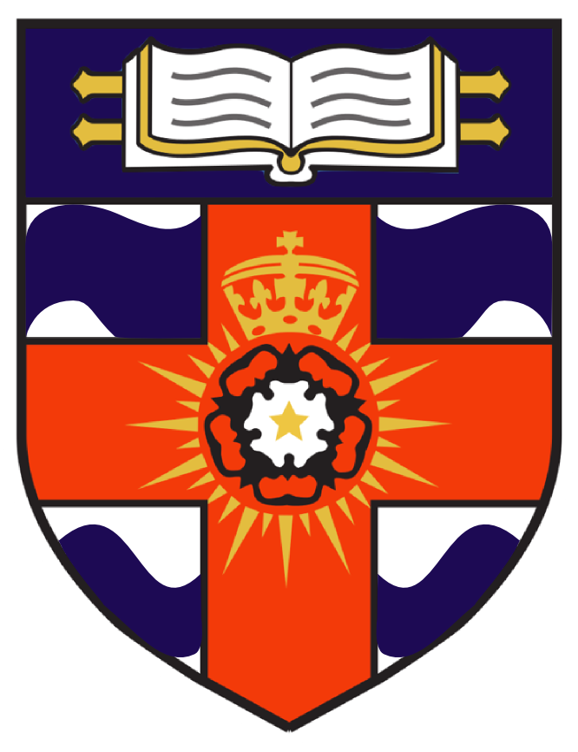
This summer, LUCA established a brand new athletics club; Motspur AC. The club is open to all alumni of LUCA clubs. It is named after the Motspur Athletics Stadium, which was the home of the University of London athletics club throughout most of the 20th century. The clubs crest incorporates the University of London shield and the Greater London shield – thus representing the whole LUCA community.
The club is a way for graduates to stay involved in the university athletics community and to compete as a team in fixtures across the year. Motspur also helps to fund the clubs by donating 50% of each member’s fees to their alma mater club. This means that for every former member that signs up to Motspur, your club gets £10 per year. We also offer members to make a donation to their alma mater club.
More information about the club can be found here: www.motspurac.com or by emailing motspur@london-athletics.com.

2016-17 Schedule

October
Council Meeting: Wednesday 12th, 7pm, Student Central Malet Street, WC1E 7HY
London Colleges League 1: Wednesday 19th, 15:00, Parliament Hill Fields
November
London Colleges League 2: Wednesday 2nd, 15:00 Mitcham Common
This Girl Can: Thursday 10th
London Colleges League 3: Wednesday 16th, 15:00 Wimbledon Common
LUCA Indoor Championships: Sunday 27th, 13:00
December
London Student’s Run, Sunday 4th December, 10:00, Queen Elizabeth Olympic Park
Motspur Christmas Meal: TBC
January 2017
Council Meeting: 20th, 7pm, Student Central Malet Street, WC1E 7HY
London Colleges League 4: Wednesday 25^{th,} 15:00, Alexandra Palace
February
BUCS XC Championships: Saturday 4th, Sheffield.
BUCS Indoor Championships: Friday 17th – Sunday 19th
March
London Colleges League 5: Wednesday 1^{st,} 15:00, Bushy Park
LUCA Outdoor Series, Stage 1: 18th or 19th
April
LUCA Outdoor Series, Stage 2: Sunday 16th
BUCS Outdoor Championships 29th – 1st May
May
LUCA Outdoor Series Final: Saturday 27th
AGM and Awards Night: Sunday 28th

